California Health Care Foundation’s Indirect Cost Policy

The California Health Care Foundation has updated its indirect cost (IDC) policy to better align with best practices in the field of philanthropy and with its own values of equity and transparency. As part of our process, CHCF analyzed its portfolio of grantees and concluded that an IDC rate of 20% is applicable to the majority of its nonprofit grantees. (A summary of this analysis is available on CHCF’s website.)

Applicability and Exceptions
For project grants issued on or after July 1, 2024, CHCF has adopted the following policy:

- Nonprofit organizations (except colleges, universities, and hospitals) and government entities may request an IDC rate of up to 20% without question. Requests for an IDC rate above 20% will be considered on a case-by-case basis.
  - A grantee requesting an IDC rate above 20% should speak with their program officer to discuss their request. CHCF will request additional details to understand how the grantee calculates its IDC rate.
- Nonprofit colleges, universities, and hospitals are capped at 20% in indirect costs for project grants. This cap also applies when the college, university or hospital is a sub-awardee.
- Consultants, subcontracts, and subawards should be excluded from direct project costs on which the IDC rate is applied.
- The policy does not apply to for-profit entities or individual consultants.
- The policy does not apply to general operating support grants, conference and event sponsorships, or stipends, which do not require grantees to identify direct and indirect costs.

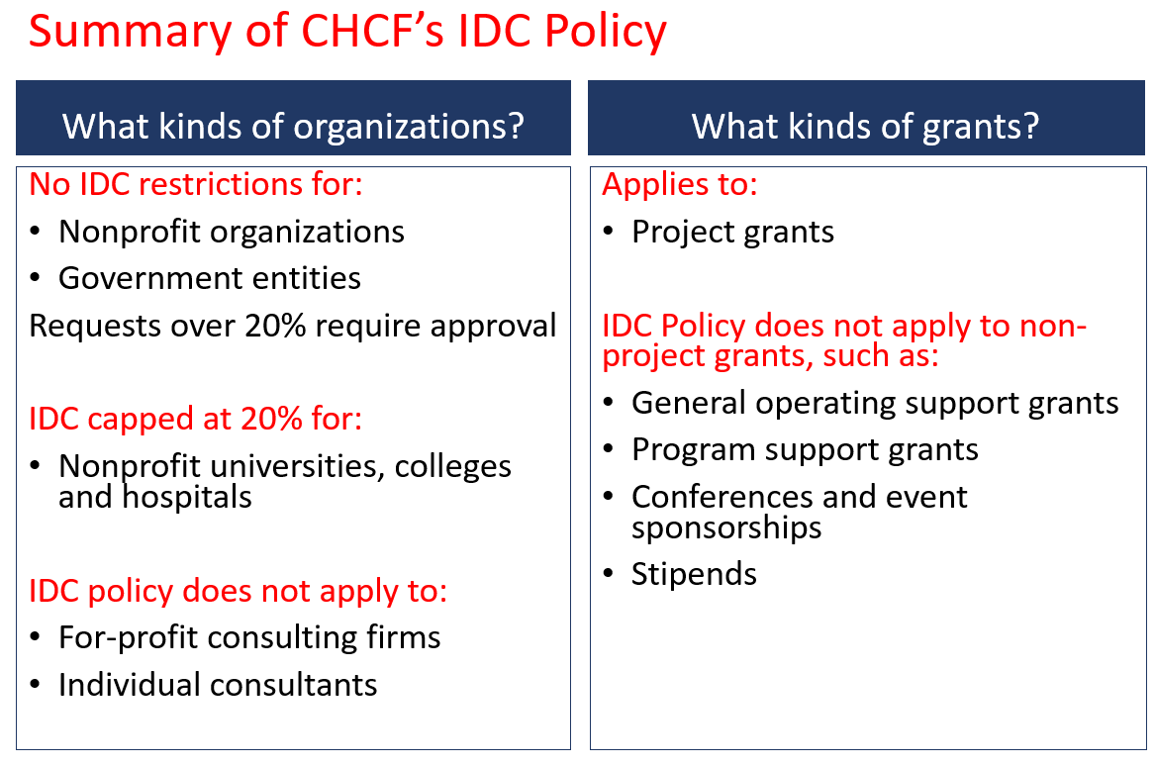

Cost Definitions
CHCF’s definitions and categorizations of costs may not be the same as those of other private or public funders, and are not the same as those used in negotiating a federal Negotiated Indirect Cost Rate Agreement (NICRA).
- Direct. CHCF defines direct costs as those specifically identifiable and directly attributable to work conducted under a project, such as personnel costs, project supplies and materials, and travel costs. Direct costs may also include the program-related portion of costs that support multiple organization functions, such as facilities, utilities, and telephone/internet services (sometimes referred to as shared or allocated costs).

- Indirect. CHCF defines indirect costs as general and administrative costs of an organization that are not specifically identifiable or directly attributable to the work conducted under a funded project.

Indirect Cost Rate Calculation
- An organization’s indirect cost rate is the ratio of the organization’s total (organization-wide) indirect costs to its total direct costs.

Total Indirect Cost
IDC Rate (%) = -------------------------
Total Direct Cost

- Project budget indirect costs are the sum of the budget for personnel and other direct costs times the grantee’s IDC rate. Consultants, subcontracts, and subawards should be excluded from direct project costs on which the IDC rate is applied. CHCF defines consultants and subcontracts as contracts for services or for goods that are definite and identifiable segments of the scope of work of a project, and a subaward as a financial award or grant issued by the grantee.

Example: A $25,000 project budget might include $10,000 for personnel and benefits, $8,000 for meeting costs, $2,000 for travel, and $5,000 for a subcontract. If an organization’s IDC rate is 20%, indirect costs would be calculated as 20% of $20,000 (all costs except the $5,000 subcontract), which is $4,000.

Grantees are encouraged to bring any questions about CHCF’s IDC policy to their CHCF program officer or to CHCF’s grants administration team (grants@chcf.org). For more resources on determining an organization’s IDC rate, please see the Funders for Real Cost, Real Change’s Indirect Cost Rate Guide (PDF).

